Week8_Git Hands-On Lab: Using .gitignore (GitDemo)

Objective:
Create a “.log” file and a log folder in the working directory of Git. Update the .gitignore file in such a way that on committing, these files (.log extensions and log folders) are ignored.

Phase 1: Initial Git Configuration
Step 1: Verified Git Version
git version
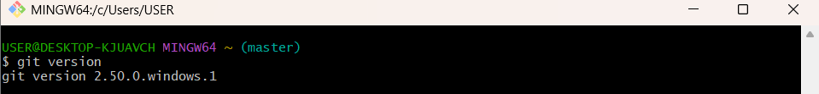
Step 2: Set Your User Name: This name will be associated with your commits.
git config --global user.name https://github.com/SaguturuShruthi
Step 3: Set Your User Name: This email will be linked to your commits.
git config --global user.email krishnashruthi2004@gmail.com
Step 4: Configured User Information
git config --global --list

Phase 2: Environment Setup: Integrating Notepad++
Step 5: Confirmed notepad++ Command Not Found Error
Step 6: Added Notepad++ to Environment Path
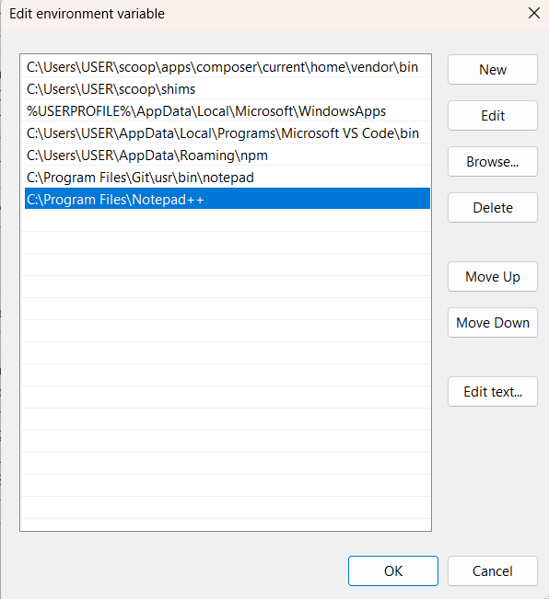
Step 7: Set Notepad++ as Git's Core Editor
git config --global core.editor "notepad++.exe -multiInst -nosession"

Step 8: Verify the Editor Configuration: To confirm the setup, run this command.
git config --global -e
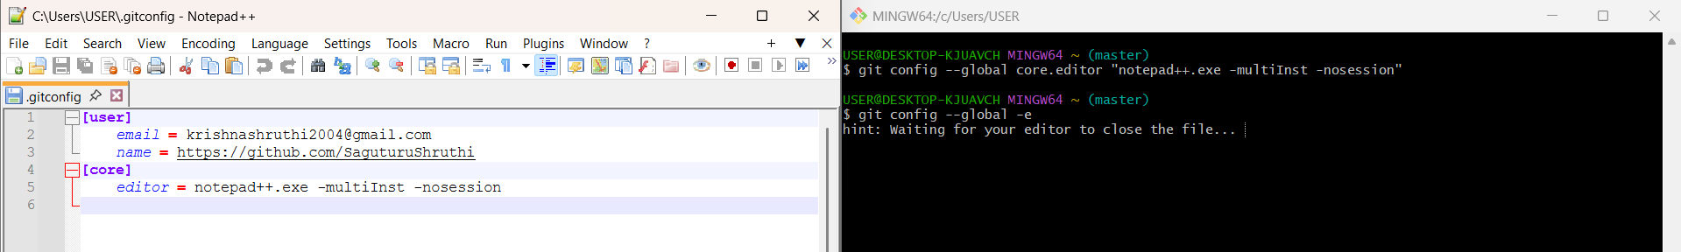

Phase 3: Local Repository Management
Step 9: Navigate to your Project Directory:
- You should continue working in the same GitDemo project folder from the last exercise. Use the cd (change directory) command to get there.
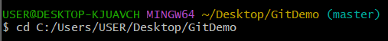
Phase 4: Creating Files and a Folder to Ignore
Step 10: Create a .log file: This command creates a file named app.log.
echo "This is a sample log entry." > app.log
Step 11: Create a log folder: This command creates a new directory named log.
mkdir log
Step 12: Create a file inside the log folder: To make the example more realistic, let's put a file inside the new log directory.
echo "Another log file." > log/system.log
Step 13: Verify the files were created: Use the ls -R command to list all files and folders recursively.
ls -R
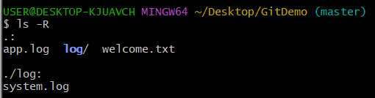
Step 14: Check the status of your repository.
git status
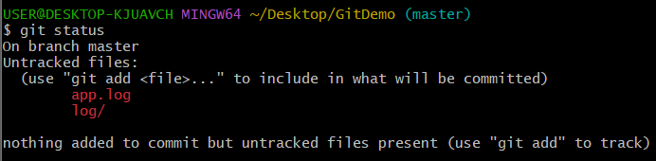

Phase 5: GitHub Remote Repository Integration
Step 15: Create the .gitignore file: You can create it using the touch command.
touch .gitignore

Step 16: Open the .gitignore file in Notepad++: This will open a blank .gitignore file in your editor.
notepad++ .gitignore
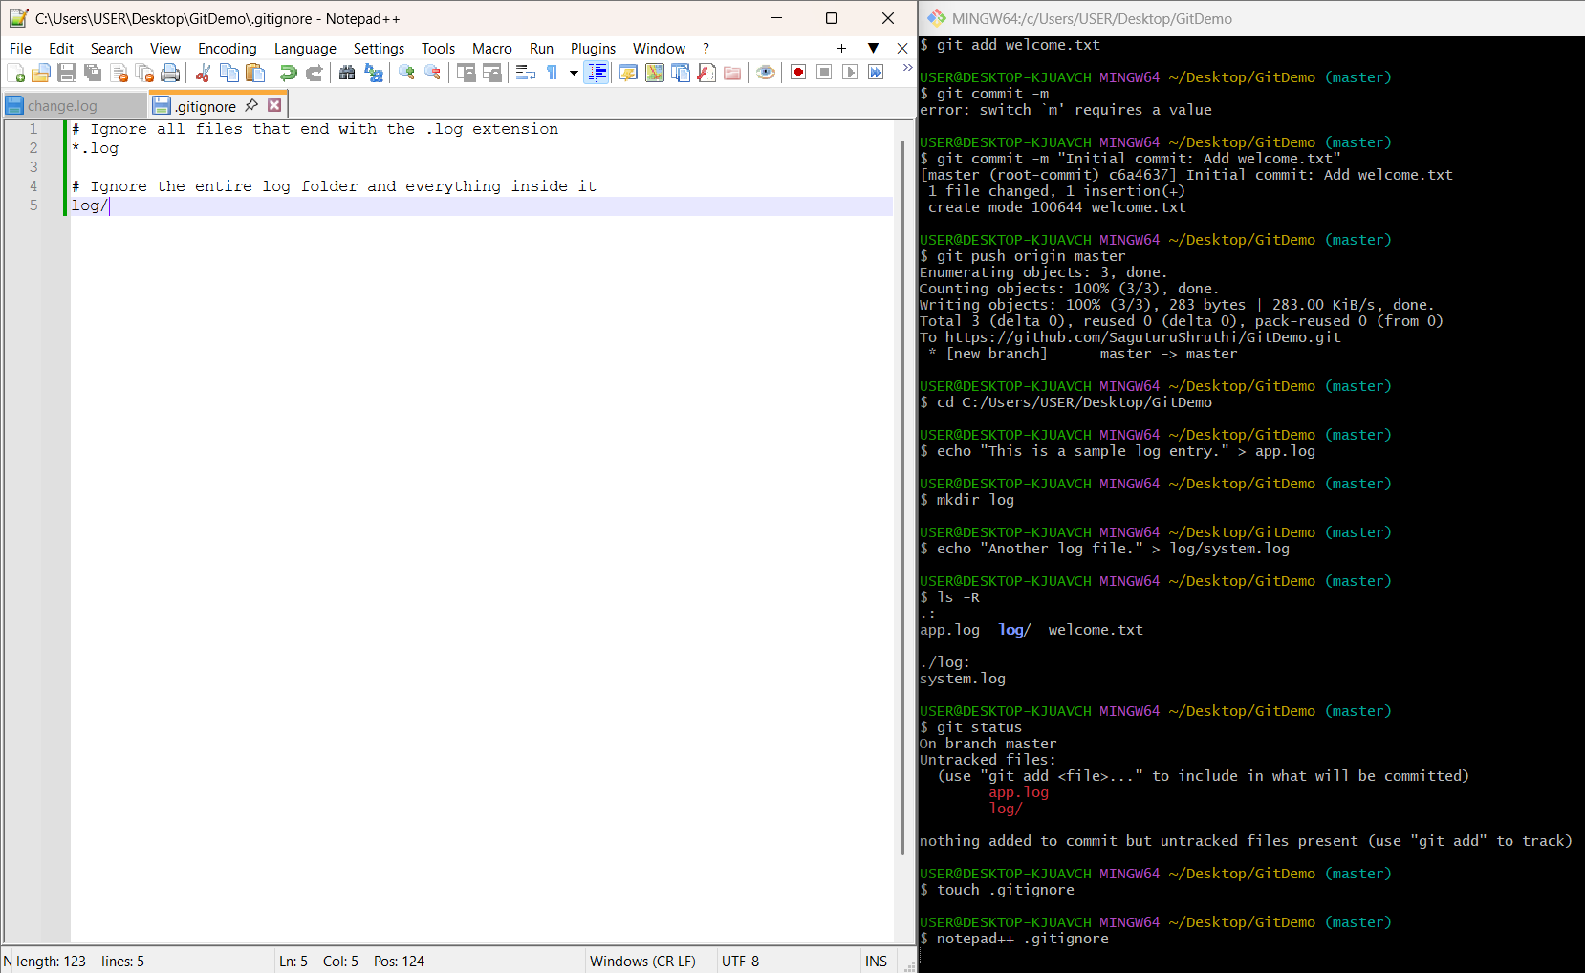
Phase 6: Verifying the Solution
Step 17: Run git status one more time.
git status
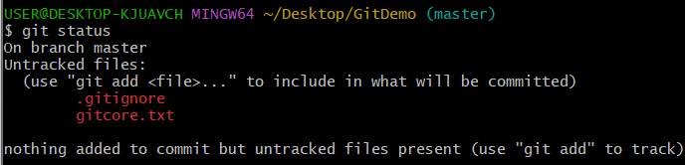
Step 18: Add the .gitignore file to the staging area:
git add .gitignore
Step 19: Commit the staged file:
git commit -m "Add .gitignore to exclude log files and folder"
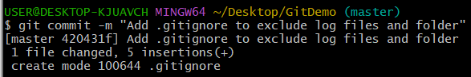
Step 20: Push the new commit to your remote repository on GitHub:
git push origin master
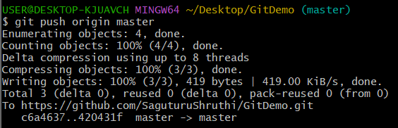

Fiinal Verification:
